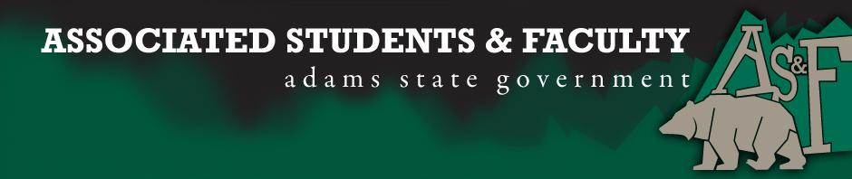

Adams State University Associated Students and Faculty Legislature
Bill Number: ASF1516033

Club Name: The Pen and Inkwell Writer’s Guild
Event Name or Trip Destination: Los Angeles, CA. Association of Writers & Writing Programs Conference (AWP)
Total Amount of AS&F Funding: $2,669.59
Total Club Points: 81 points
Author: Nicholas Spencer
Sponsor: Matthew Tulley (GAB Senator)

Event or Trip Information
Who: Robert Affeldt, Nicholas Spencer, Tabby Richardson, Jasmyn Brendle, Amanda Martinez, Amie Chadwick, Nick Smith, Rebecca Carey, Julia Cole, Laura Bell, Alphonso Arroyo, Johnathon Hazard, Johnathon Payne.

What: The AWP Conference & Bookfair is an essential annual destination for writers, teachers, students, editors, and publishers. Each year more than 12,000 attendees join our community for four days of insightful dialogue, networking, and unrivaled access to the organizations and opinion-makers that matter most in contemporary literature. The 2015 conference featured over 2,000 presenters and 550 readings, panels, and craft lectures. The bookfair hosted over 800 presses, journals, and literary organizations from around the world. AWP’s is now the largest literary conference in North America.

Where: Los Angeles Convention Center & JW Marriott Los Angeles

When: March 30-April 2, 2016

Why: As a collection of creative writing students here at Adams State University, we glanced, perused, and drifted around campus in search of opportunities for our major. We came to the conclusion there is not much money invested in our department, thus opportunities for us are far and few in between. We are a new club in search of growth, fresh experiences, and leaving a lasting tradition for creative writing students for years to come. We want creative writing students to be excited about their major and the opportunities surrounding them outside the San Luis Valley.

We, as authors, want to be the best literary authors possible. We need to broaden our horizons and be around like minded people. Without provocative discussion and challenges from established authors we are missing out on essential growth. Without learning about publishing, separate publishers, and the trends of literature we can be at an extreme disadvantage after graduation. The literature world is intellectually competitive, and it is imperative we seek out the Mecca of writing to elevate our skills in a competitive market.

The language up to this point has been very singular regarding creative writing. We have several members who are not creative writing majors. We have band, mass communication, psychology, teacher education, and nursing in addition to creative writing majors. The similarity among us all is the passion for expression and craving for stellar literature. We are a genuine campus-wide academic club. We are always spreading our reach further and further. We welcome anyone interested to come and participate.

Why? We deserve as much right to growing and developing as individuals as anyone else on campus. Although there is few opportunities for our department, it does not mean we will accept it. We will apply for and take opportunities as much as possible. The chance to become as qualified in our field as a wildlife biologist or accountant is dependent on getting out and challenging our skills. Because we are accountable for our future and are taking responsibility for a better tomorrow, that’s why.

Author Contact Information: (719)494-5610 spencernb@grizzlies.adams.edu

Account Information: 3200-854-7630-1900

Additional Information: The Pen and Inkwell Writer’s Guild is very active on campus. We were at all the homecoming events with punctuality and numbers. We have attended one club fair this school year recruiting and connecting students with major-appropriate clubs. In addition to campus activities, we have volunteered in the community in association with ASU Cares, and Kaboom. We have had tried World’s Famous Chocolate and have been discussing a craft fair in cooperation with a local book fair. Aside from fundraising, we provide weekly workshops for all writers. Our events this year include readings at Cozy Café, Open Mic Night: Inequality for All, and Blind Date with a Book. We are in the process of new fundraisers (Finals Massage, Spaghetti Dinner, Food Baskets, etc.). We are excited for an upcoming event we hope to complete at the CASA House. We will be hosting a writing retreat and publishing the revised works from the retreat. We hope this will be our annual fundraiser. Chap books will be available for purchase.

Assessment Rubric:
What do you want people attending the event, program, or going on the trip to gain from this experience? (Required for funding requests) (Check/circle all that apply)

- Expanding the Learning Experience
  - Attending and making connections with authors and publishers
- Analytical Reasoning
  - Comparing concepts and ideologies to works of literature and understanding authors morphing of themes, topics, and devices.

- Internal Self-Development
  - Identifying with other students and authors to develop a sense of identity
- Improving Teamwork and Leadership
- Community Service and Civic Engagement
  - Learn better methods for community outreach
- External Skill Development
  - Hands on experience with networking, critical thinking, resume building, applying for higher education, and publishing.

I, Nicholas Spencer, present this bill for consideration of and approval by the Associated Students and Faculty Senate, this 15th day of February, 2016.

Implementation: Upon approval, be it enacted that:
- The proposed bill become adopted in favor of recognition by the AS&F Senate, and that:
- Pen & Inkwell be funded $2,669.59

VOTE: Yeas_____ Nays______ Abs_______
Complete applicable sections:
- ADOPTED at ______________ meeting of the AS&F Senate on ___________.
- BILL did not pass at ______________ meeting of the AS&F Senate on ________.
- BILL will be reconsidered on ___________________.

Approved/Disapproved by AS&F President
_______________________________

