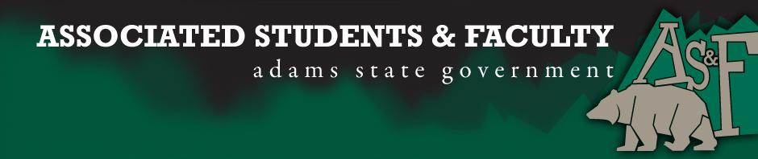

Adams State University Associated Students and Faculty Legislature
Bill Number: ASF1516031

Club Name: Geo Club
Event Name or Trip Destination: Association of American Geographers Annual Conference, San Francisco, CA.
Total Amount of AS&F Funding: $6,962.16
Total Club Points: 69
Author: Jordan Yatska
Sponsor: Cameron King (Poker Club Representative)

Event or Trip Information
Who: Geo Club memebers
What: Attending AAG (Association of American Geographers) annual conference in order to present orgional research, connect with future employers, and attend lecture sessions on cutting-edge research.
Where: San Francisco, CA
When: March 29th-April 2nd
Why: Funding to attend the meeting, present research, and learn from researchers who are in the forefront of their fields.

Author Contact Information: jordanyatska@gmail.com, 501-238-0259

Account Information:
AS&F account: 3200-871-7630-1900

Additional Information: 1 attendee will be presenting new research. 4 years in a row Geo Club has represented Adams State at national geoscience conferences where faculty, alumni, and current students display the quality of the Adams State has to offer.

Assessment Rubric:
What do you want people attending the event, program, or going on the trip to gain from this experience? (Required for funding requests) (Check/circle all that apply)

· Expanding the Learning Experience
· Analytical Reasoning
· Internal Self-Development
· Improving Teamwork and Leadership
· Community Service and Civic Engagement
· External Skill Development

Please define how your event, program, or trip will help people gain from this experience according to the goals you have checked.
(Please define only the boxes checked)

Attending the annual AAG conference will afford ASU students with opportunities to promote its science programs, while allowing students to explore educational and research endeavors. This translates back to the ASU community with the skills and knowledge taken from the conference, by which the Adams State Earth Science programs will continue to advance undergraduate research. Further, the information exchanged at this conference will broaden students’ knowledge base from the larger scientific body. This in turn, aids in developing the skills needed to be successful as an earth scientist.

I, (Jordan Yatska), present this bill for consideration of and approval by the Associated Students and Faculty Senate, this 15th day of February, 2016.

Implementation: Upon approval, be it enacted that:
- The proposed bill become adopted in favor of recognition by the AS&F Senate, and that:
- Geo Club be funded $6,962.16

VOTE: Yeas_____ Nays______ Abs_______
Complete applicable sections:
- ADOPTED at ______________ meeting of the AS&F Senate on ___________.
- BILL did not pass at ______________ meeting of the AS&F Senate on ________.
- BILL will be reconsidered on ___________________.

Approved/Disapproved by AS&F President
_______________________________

