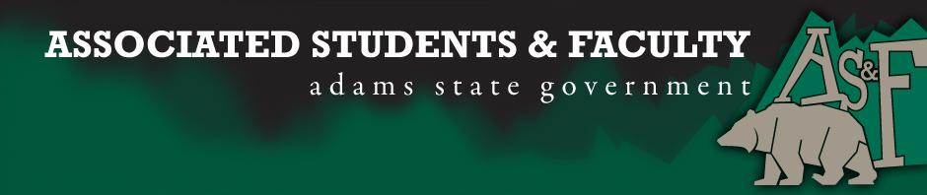

Adams State University Associated Students and Faculty Legislature
Bill Number: ASF1516030

Club Name: Adams Atoms Chemistry Club
Event Name or Trip Destination: 2016 National ACS Conference
Total Amount of AS&F Funding: $2,338.60
Total Club Points: 57
Author: Samantha Sargent
Sponsor: Cari Steen (Chemistry, Computer, and Math Senator)

Event or Trip Information

Who: Adams Atoms Chemistry Club (8 student members)
What: 2016 National American Chemical Society Conference
Where: San Diego, California
When: March 13-17, 2016
Why: The ACS conference provides students with a great opportunity to observe the newest advances in Science and Technology. Furthermore, opportunities are provided by talking to industry leaders and research universities, which will help with furthering the student’s career path. We have two students that will be presenting their research at the conference.

Author Contact Information: sargentsl@grizzlies.adams.edu

Account Information: 3200-846-7630-1900

Additional Information: The conference provides a great way to network, learn more about graduate programs and career opportunities and a chance to look at the countless areas of research being conducted by chemists from all across the United States.

Assessment Rubric:
· X Expanding the Learning Experience
· Analytical Reasoning
· X Internal Self-Development
· X Improving Teamwork and Leadership
· Community Service and Civic Engagement
· X External Skill Development

Please define how your event, program, or trip will help people gain from this experience according to the goals you have checked.

Expanding the Learning Experience – Attendees of the conference have the opportunity to attend hundreds of research presentations from professionals and graduate students, workshops, dozens of expositions, research talks from fellow undergraduates, and graduate school college fair. In addition to attending events, students have to opportunity to present their own undergraduate research and network with thousands of other undergraduate students and college professors.

Internal Self- Development – Individuals are able to attend presentations that interest them personally gaining ideas for future research topics, graduate school theses and future career opportunities. Students also have the chance to meet with graduate professors and graduate school admissions counselors to discuss future education ideas.

Improving Teamwork and Leadership – At the conference, students join forces to help teach other students fun chemistry activities during the Chemistry Demo Exchange. Undergraduates are able to present their own research as well speak with professors and other undergraduate students at the “Poster Session.” In order to attend the conference, the student members of the club must work together to fundraise and organizing our travel plans.

External Skill Development – Research presentations and workshops are a great way to develop many skills like how to appropriately ask questions and how to talk to professionals in our field. In addition to what we gain from the conference itself, we learn many other skills like organizing the traveling for this event, raising money, organizing events during our travel such as getting a tour of a professional facilities.

I, Samantha Sargent, present this bill for consideration of and approval by the Associated Students and Faculty Senate, this 15th day of February, 2016.

Implementation: Upon approval, be it enacted that:
- The proposed bill become adopted in favor of recognition by the AS&F Senate, and that:
- Adams Atoms Chemistry Club be funded $2,338.60

VOTE: Yeas_____ Nays______ Abs_______
Complete applicable sections:
- ADOPTED at ______________ meeting of the AS&F Senate on ___________.
- BILL did not pass at ______________ meeting of the AS&F Senate on ________.
- BILL will be reconsidered on ___________________.

Approved/Disapproved by AS&F President
_______________________________

