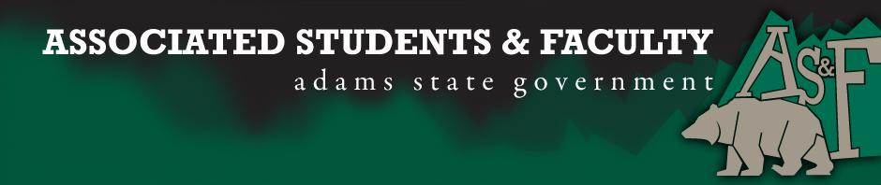

Adams State University Associated Students and Faculty Legislature
Bill Number: ASF1516000

Club Name: PBL
Event Name or Trip Destination: State Leadership Conference
Total Amount of AS&F Funding: $2894.56
Total Club Points: 70
Author: Danielle Quintana
Sponsor: John Owsley

Event or Trip Information
Who: All 22 PBL Club Members and our advisor Natalie Rogers
What: Colorado PBL State Leadership Conference
Where: Colorado Technical University Colorado Springs Campus
When: April 7-10, 2016
Why: To receive funding that will allow our member to attend the state leadership conference and qualify for the national leadership conference in June.

Author Contact Information: asupbl@grizzlies.adams.edu

Account Information: 8680-xxx-2520

Additional Information:

Assessment Rubric:
What do you want people attending the event, program, or going on the trip to gain from this experience? (Required for funding requests) (Check/circle all that apply)

· X Expanding the Learning Experience
· Analytical Reasoning
· X Internal Self-Development
· X Improving Teamwork and Leadership
· Community Service and Civic Engagement
· External Skill Development

Please define how your event, program, or trip will help people gain from this experience according to the goals you have checked.
(Please define only the boxes checked)

Expanding the Learning Experience
It allows us to meet and compete with members from across the state in over 60 different competitive events. We learn about different leadership opportunities and how to bring back being a leader to our campus.

Internal Self-Development
Being able to attend this conference will allow each one of members to develop as a leader and be able to compete in different competitive events that will not only help them in their everyday lives but in their college experience as well.

Improving Teamwork and Leadership
Attending this conference, we will see multiple different key note and motivational speakers that will allow us to improve our leadership skills in different areas. We will then take what we learn and be able to bring it back to the campus and to all of the other clubs and organizations that we are a part of.

I, Danielle Quintana present this bill for consideration of and approval by the Associated Students and Faculty Senate, this (Meeting Day) day of (Meeting Month), 20 (Meeting Year).

Implementation: Upon approval, be it enacted that:
- The proposed bill become adopted in favor of recognition by the AS&F Senate, and that:
- Phi Beta Lambda (PBL) be funded $5065.48

VOTE: Yeas_____ Nays______ Abs_______
Complete applicable sections:
- ADOPTED at ______________ meeting of the AS&F Senate on ___________.
- BILL did not pass at ______________ meeting of the AS&F Senate on ________.
- BILL will be reconsidered on ___________________.

Approved/Disapproved by AS&F President
_______________________________

